Environmental aspects in light of the MSCA Green Charter
- Research content and impact
- Fill in according to the topics of your proposal
- Research practice (inspired by Ligozat's "Ten simple rules for more sustainable research")
Guideline: Environmental sustainability in the planning and implementation of the proposed research, covering the three core dimensions of sustainability: environmental responsibility, social equity and economic viability.
- Reducing the carbon footprint of participating laboratories: Remote participation in meetings whenever travel can be avoided, minimising travel through smart planning of secondments and meetings.
- Should the purchase/replacement of electrical laboratory equipment be necessary, systems with the lowest energy consumption will be selected and standby mode will be avoided where possible.
- Responsible planning and implementation (collaborative and reproducible work): In developing this proposal, we conducted a thorough literature review to identify useful related work and identify relevant knowledge gaps and research questions, as outlined in the "Excellence" section in Part B1.
- Planning a statistically significant number of tests and controls to avoid ambiguous results and subsequent repetitions
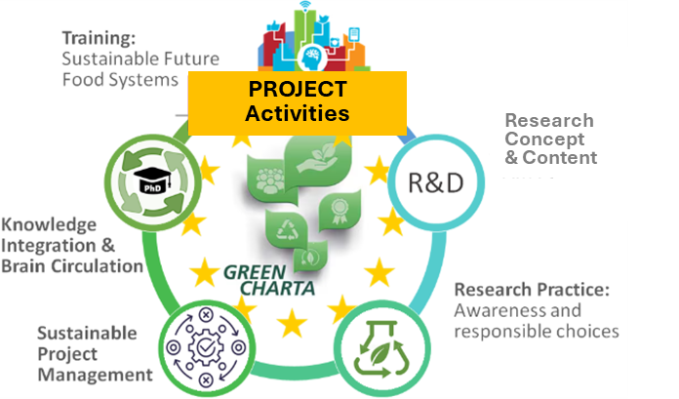
- Applying the FAIR principle (Findable, Accessible, Interoperable, Re-usable), the primary data sets will be made publicly available together with their metadata (after publication). This not only ensures reproducibility and transparency, but also promotes secondary use of the data and ensures optimal use and maximum impact of research funds.

- All PIs/supervisors promote sustainable ideas and initiatives from the bottom up and empower their DCs/teams to collaborate and reflect on their actions. This also includes transferring environmentally friendly and sustainable habits from the private sphere to the laboratory, e.g.: limiting the use of disposable materials (plastic); prudent printing (thinking before printing and collecting printed documents); using sustainable means of transport, e.g. public transport, carpooling; preferring local, seasonal and vegetarian food when organising events; using digital media wisely (preferring shared workspaces instead of frequently exchanging documents by email); using materials for as long as possible and considering donations when otherwise functional equipment is no longer suitable for research purposes.
- Education-related
- The project will raise awareness of environmental issues and the necessary transition to more sustainable and resilient food systems. By incorporating "green aspects" into the training of doctoral students, we promote sustainable thinking and support and guide MSCA researchers in monitoring and minimising the environmental impact of their respective research activities and results.
- A research and innovation (R&I) mindset aligned with the United Nations Sustainable Development Goals (SDGs) has been crucial in shaping the project's training programme. To promote the sustainable implementation of DeepTech technologies, each training block includes a seminar focused on improving the life cycle inventories (LCI) of ... technologies for which important data is currently lacking. During the training sessions, the DCs discuss and evaluate data sets from their own work and contribute high-quality data for life cycle assessments (LCA) that have been carried out. After quality assurance and publication, all data sets are compiled and stored centrally for secondary use. As open source, they are available to the wider scientific community.
- Whenever possible, the training courses are offered online (ePortfolio) or in compact one-week boot camps to ensure accessibility and inclusivity and to reduce the ecological footprint caused by travel to different training locations.
- In line with the European Commission's Startup Village initiative, selected rural areas with a startup ecosystem serve as training locations to complement/shape the non-academic perspective and entrepreneurial mindset, such as ... Other startup ecosystems will be contacted once the excursions for each of the boot camps have been planned in detail.
- The training courses will also introduce sustainable management tools, e.g. environmental management systems (the global standard ISO 14001 and environmental management and audit systems), life cycle assessments (LCA), tools and frameworks that help organisations/regions establish and monitor sustainable supply chain management and circular economy practices, corporate social responsibility (CSR) frameworks, or green certifications/labels.
- Environmental aspects at management level
All consortium members, including DCs and participating staff, will actively participate in all aspects of implementing the provisions of the MSCA Green Charter. This includes, for example:
- Promoting environmentally friendly procurement of sustainable materials as an alternative to single-use plastics.
- Using creative teleconferencing and hybrid conference tools and avoiding unnecessary travel.
- The consortium management will ensure that all programme-related events requiring physical attendance are organised as sustainably as possible, taking into account the number and duration of events, the venue, travel, accommodation, catering, handouts, etc. DCs and PIs will also be involved in local event planning to use their local knowledge to promote low-carbon transport, identify optimal travel routes or, where unavoidable, use direct connections to minimise the project's environmental footprint.
- Promoting awareness of sustainability issues related to the project, as outlined in the DEP (Dissemination and Exploitation Plan). Novel ideas and examples of best practices for improving the sustainability of research projects/programmes will be shared via social media to inspire others to reduce the environmental impact of their research and research-related activities.
- Train travel is preferred over air travel when time and cost are reasonable.
- Email correspondence should be reduced to the essentials – a first step is to raise awareness among both teams of the use of a secure data and information platform (e.g. NextCloud).
- Knowledge integration and circulation: Networking during boot camps and events, exchanges between laboratories and the integration of DCs into various R&D environments help to accelerate and disseminate scientific findings more quickly, rather than developing them in parallel in different laboratories. This saves resources and benefits both individual researchers and the research community.

